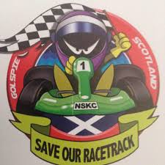
NORTH OF SCOTLAND KART CLUB
LITTLEFERRY RACE CIRCUIT
GOLSPIE

APPLICATION FOR 2019 CLUB MEMBERSHIP

Name
Address
Postcode
Tel (landline) |  | Tel (mobile)
Email

FAMILY MEMBERSHIP - please give the names of family members to be included on this membership (family – means all living under the same address).

MEMBERSHIP FEE - £100.00 if paid before 28/02/2019, thereafter £130.00

By signing below, you are expressly consenting and agreeing to the information given being stored electronically. We will use your information to manage your membership, process event entries and payments, and to email you with reminders, news and offers. Our Privacy Policy is available on the club website. We may also share the information with relevant kart clubs, kart schools, kart associations and the Motor Sports Association but will not otherwise sell or transfer your details. If the driver is under 16 you are also giving specific permission for their details to be similarly stored and used.
Signed | Date

If you want to pay by Bank Transfer, our Bank Details are Sort Code 82-65-01 Account 30063046, please include your Name and word Membership in the reference.

Or if paying by cheque make payable to “North of Scotland Kart Club” and forward to - Membership Secretary
Fiona Morgan
3 MacDonald Court
Culloden
Inverness IV2 7LW
Telephone 07545 185164 Email – fionacmorgan@btinternet.com

Membership number issued
Date |  | Paid (cash/cheque/banktransfer)

